Post deployment steps

- Create HomeLet user with “HomeLet Integration” perm set. Uncheck “send password” – there’s no need for HomeLet to have the creditials

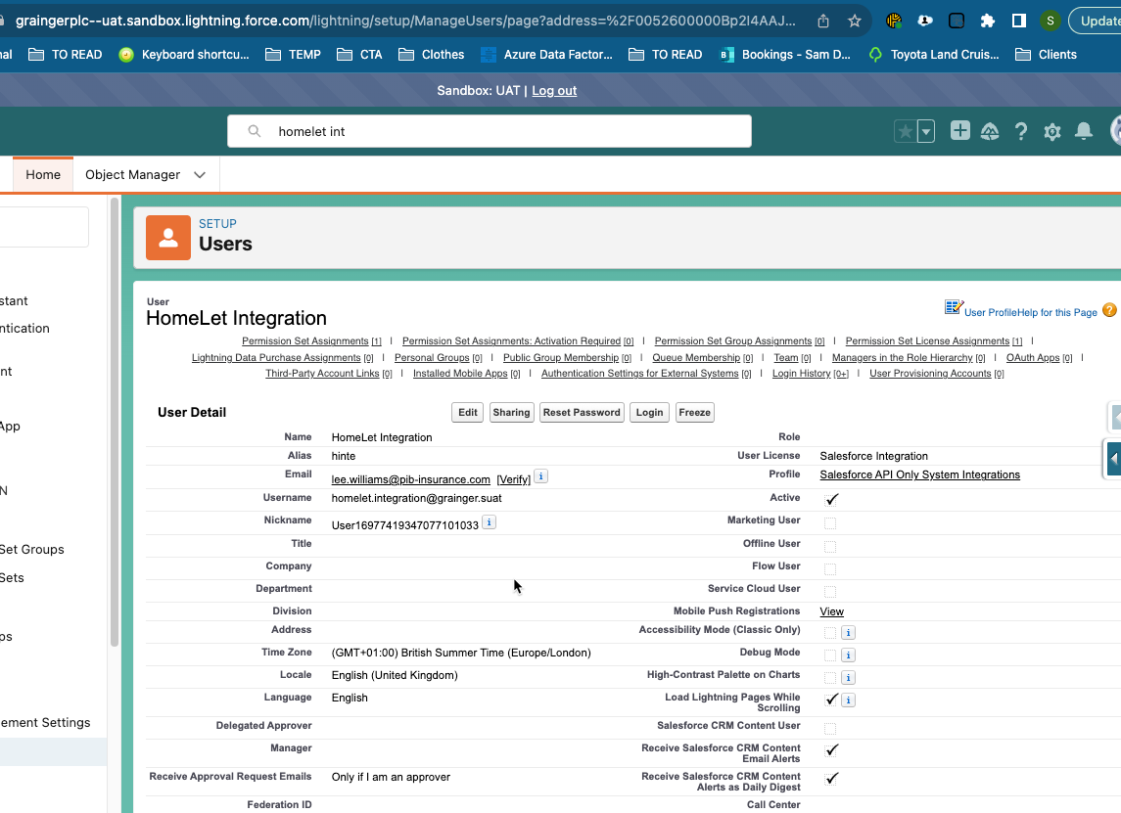

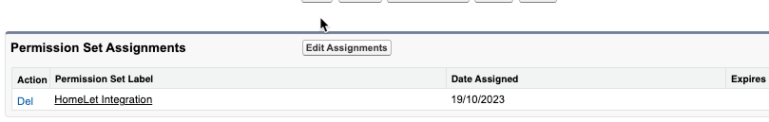

- Update HomeLet connected app to add user

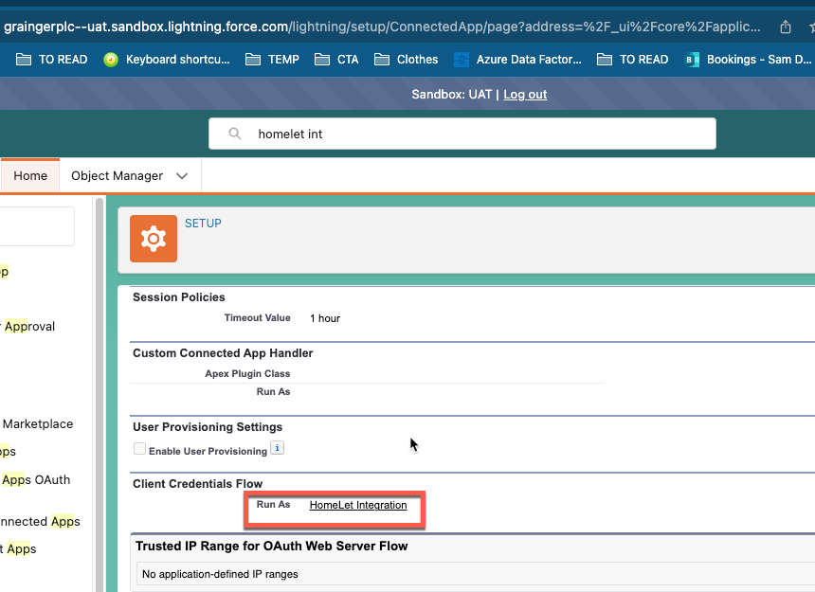

- Update AgentId in VisionPlus connected app (HomeLet to supply correct value)
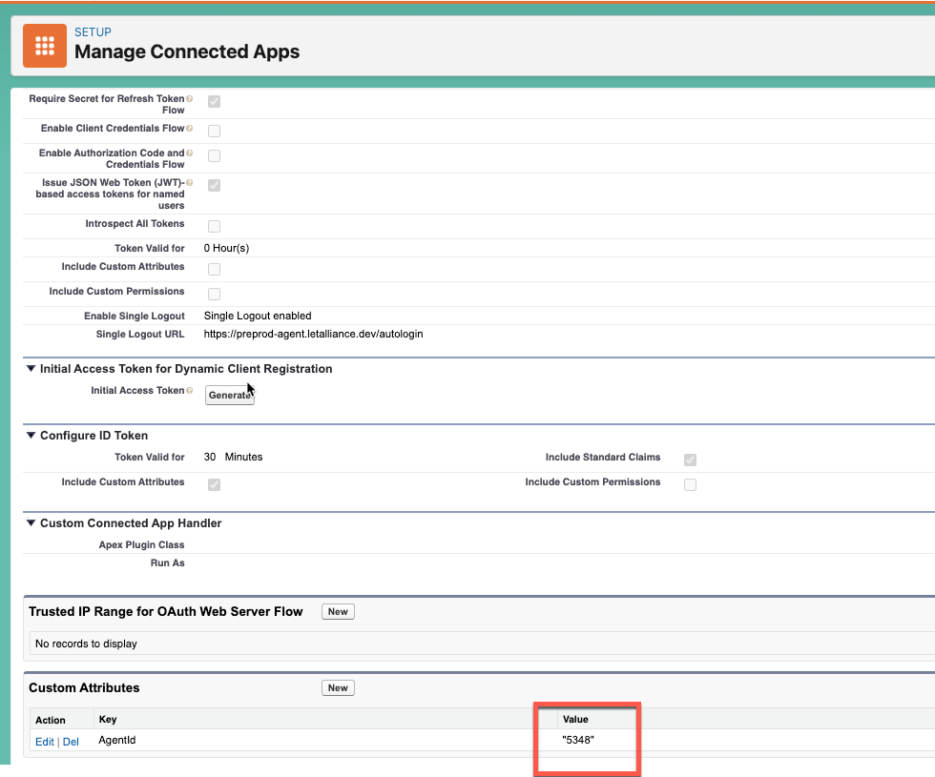
- Click “manage app” for VisionPlus connected app and create custom scopes as below
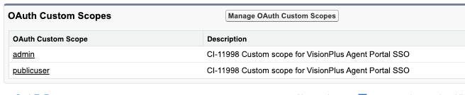
- After clicking “manage app”, then click “edit policies” and setup JWT as below
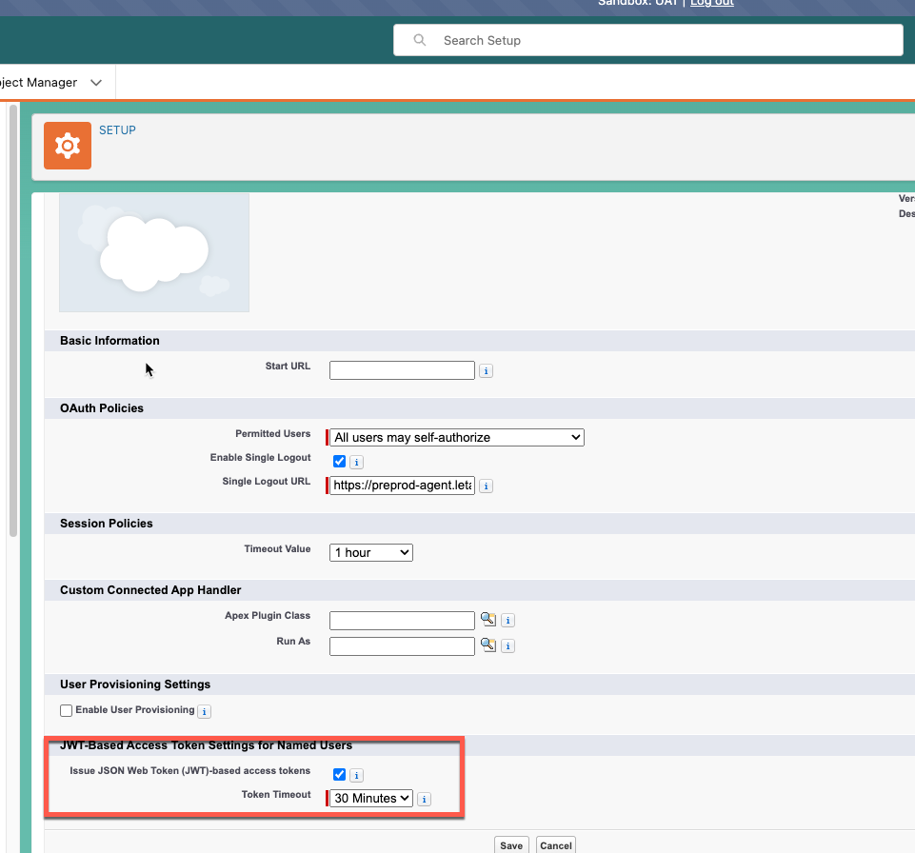
- Setup CORS for URL and enable for OAuth endpoints as below
- 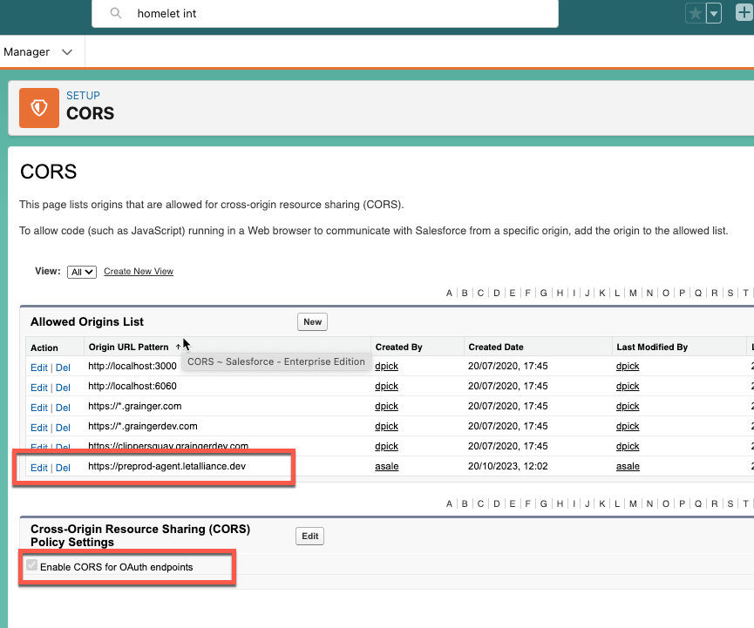

Anjali's Deployment Notes
- Deploy the validated package in gearset using env vars changes
- manually updated OCR related list fields
- lightning page - enabled dynamic actions from opportunity page layout.
- updated filter conditions on buttons
- updated filter conditions for vmTrackingScreen component
- Updated existing custom setting value for this new field - $Setup.Configuration__c.Referencing_Provider__c
- updated Callback URL value of Referencing_HL_Auth_Setting__mdt. It should match the Callback URL of auth provider.
- update values of Referencing_HL_Auth_Setting__mdt if needed
- check remote site setting link if needs updating in production
- go to Referencing HL Ext Creds - under Principals --> actions --> authenticate
- assign permission set Referencing HL Callout to users

